Assignment of Chapter 8
Confidence Interval

- What factors will affect the width of confidence Interval? How do they affect?

2. For a given confidence interval, which of the following is the interpretation of a 96% confidence level?
A) 96% chance that the given interval includes the true value of the population parameter
B) Approximately 96 out of 100 such intervals would include the true value of the population parameter
C) 4% chance that the given interval does not include the true value of the population parameter
D) Both "a" and "c" are true

3. Consider a random sample of size 40 from a normal distribution, given $\overline{x}=6.05, σ=2.44.$
- Set up a 95% confidence interval for the population mean $μ$.
- Will the answer in a) change a lot if the population distribution is a little skewed? Explain without calculation.

4. The UIC students’ union plans to hold a big party for the coming Christmas. To estimate the mean number of soda cans required per student in this party, the organizer randomly asked 25 UIC students and calculated the average number of soda cans required per student, which is 3.2. Assume the number of soda cans required by a UIC student follows normal distribution and the population standard deviation is known to be 1.2.
a) Calculate a 99% confidence interval for the average number of soda cans required per student in the party.
b) If 300 UIC students will attend this party, at least how many soda cans should UIC students’ union prepare?

5. The mean of the sample of 65 customer satisfaction rating in Table below is =42.95. If we let denote the mean of all possible customer satisfaction rating for the XYZ Box video game system, and assume that equals 2.64:
a) Calculate 95 percent and 99 percent confidence intervals for.
b) Using the 95 percent confidence interval, can we be 95 percent confident that is at least 42 (recall that a very satisfied customer gives a rating of at least 42)? Explain.
c) Using the 99 percent confidence interval, can we be 99 percent confident that is at least 42? Explain.
d) Based on your answers to parts b and c, how convinced are you that the mean satisfaction rating is at least 42?
Table: Composite Scores for the Video Game Satisfaction Rating Case
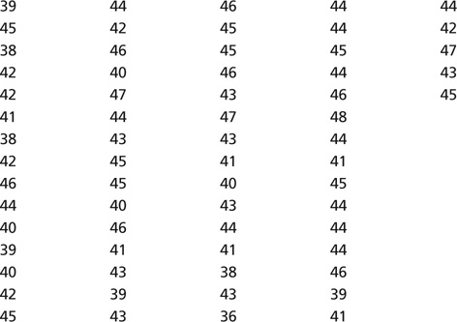

6. The owner of Huitong Egg Farm want to estimate the mean number of eggs laid per chicken. A sample of 20 chickens shows they laid an average of 20 eggs per month with a standard deviation of 2 eggs per month.
a) Give a point estimate for the population mean.
b) Explain why we need to use the t-based interval estimation. What assumption do you need to make?
c) Develop the 95 percent confidence interval for population mean.
d) Would it be reasonable to conclude that the population mean is 21 eggs? What about 25 eggs?

7. Manager of a pizza store wants to estimate their mean delivery time, he randomly selected 14 pizza orders and called their customer asking for the delivery time. The delivery time (min.) of the 14 pizza orders are as follows:
22, 15, 18, 30, 12, 31, 18, 15, 23, 13, 19, 25, 17, 32.
a) Assuming the population of delivery time is normally distributed, find a 95% interval estimate of the true population mean delivery time of this pizza store.
b) The owner of the store once claimed that the mean delivery time of his store is less than 25 minutes. On the basis of your results, do you believe this claim? Why?

8. Several UIC students are planning to develop an “App” to help UIC students do the GE course selection. They did a simple market survey in UIC by randomly asking 18 students about their willingness to pay fees for this “App”. It turned out that 10 students were definitely NOT willing to pay such fees.
a) Construct a 95% confidence interval for the proportion of UIC students willing to pay for this “App”.
b) If the proportion mentioned in a) is less than 80%, these students will stop developing this “App”. So based on your answer of a), will they continue developing this “App”?

9. In question 7, if the manager of this pizza store wants to 95 percent estimate the mean delivery time with a maximum tolerable error 5 minutes, how many pizza orders he should select as a minimum?
10. The Transportation department of an IT company is designing a new shuttle bus route for the employees, they provided two route plans (plan A and plan B) for their employees to choose. A random sample survey shows that among 35 questionnaires collected, 16 staff prefer plan A and 11 prefer plan B, the rest refused to take any of these two plans.
a) Find a 95% confidence interval for the proportion of staff who prefer plan A ($p_{A}$).
b) Find a 95% confidence interval for the proportion of staff who prefer plan B ($p_{B}$).
c) To estimate $p_{A}$ with 95% confidence, how many questionnaires should be collected to achieve a precision of $±5\%$?
d) To estimate $p_{B}$ with 95% confidence, how many questionnaires should be collected to achieve a precision of $±5\%$?

